Test Project document
  - WSC2017_TP40_Day2_EN

Submitted by:
Name: External Designer
Member country or region: N/A

Contents
This Test Project proposal consists of the following documentation/files:
- WSC2017_TP40_Day2_EN.doc
- WSC2017_TP40_Day2_Front and back cover (Folder with images and text)
- WSC2017_TP40_Day2_Articles (Folder with subfolders for spreads)
- WSC2017_TP40_Day2_Logo FK (folder with logos)
- WSC2017_TP40_Day2_Mockups (folder with image mock up files)

Introduction
What is #myFKeffect?
About FK Norway: The main activity of FK Norway is to support the exchange of employees and members between businesses and organizations in Norway, Africa, Latin America and Asia. Through innovative collaboration, our partners share knowledge, learn from each other, and build stronger bonds of cooperation. FK Norway is exclusively financed by the Norwegian National Budget, forms part of the governmental Norwegian developmental policy, and is directly subordinated the Norwegian Ministry of Foreign Affairs.

Description of project and tasks
My FK effect (#myFKeffect) is a project aiming at telling former and current FK participants stories about their experiences of being on exchange. This includes personal stories, societal experiences and reflections on how working and living in another country have changed or influenced their lives. Through these stories, we want to highlight and promote the great work our FK participants and partner organizations are doing. We make the world a smaller and a better place.
Target group:
Young professionals and volunteers from age 18-35. Adventurous, enjoy travelling, interested in social and political problems. Most of them are enrolled or have finished higher education.

Instructions to the Competitor
Create a folder on your Desktop called YY_MOD_Day2 (where YY represents the number of your workstation).
This folder structure will be as follows:
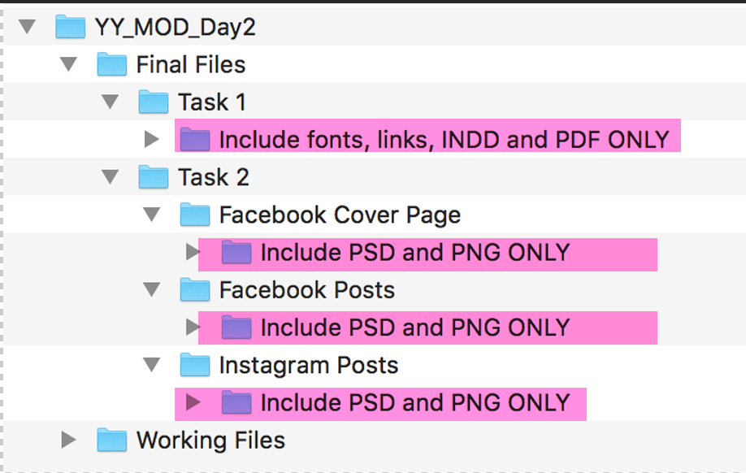
*The pink highlighted text are instructions only
You must include your workstation number on the presentation board and printouts for marking and delivery to your workstation (the number should be included outside of the artwork area)
Please note: Use a pdf when printing your proofs! The working files will be large and will take too long to print!

Task 1: Magazine layout
These are sample pages of a new magazine which you need to prepare so that somebody else may produce the rest.
Working File Format: Indesign
Final File format: PDF/X-4:2008 (Including crop marks and document bleed settings)
Magazine name: #myFKeffect
Size: A4, 8 pages.
Bleed: exactly 3mm (if needed)
Text: must include Paragraph styles for body text, title and header,
There can be no overrides.
Page numbers and front cover text do not require a style.
Additional styles may be included. Delete any incoming styles, leaving only yours in the panel.
Name the styles:
BODY
TITLE
HEADER

Each article/spread must include a header containing the person’s name and image of the person.
Master pages must include automatic page numbers and any additional design elements you see as appropriate.
The cover and each article (spread) must include an image collage (montage) with at least three images. You must ensure the quality of the colour levels (including contrast and light, so that the images show detail in the shadow areas). Each Image collage must be in one psd file with layers included (do not flatten)
Resolution of image collages in magazine: 230–260ppi (placed at 100% in Adobe InDesign)
ICC profile of image collages: Adobe RGB 1998

Front cover:
Logo - WSC2017_TP40_Day2_Logo FK
#myFKeffect
Text for front cover provided in folder WSC2017_TP40_Day2 front and back cover
No paragraph styles on cover.
Image collage in one psd file with layers including 3 images minimum from primary_images folder
You can add more images from additional_images folders of both cover and articles.
No page number required.

Back cover:
You can design this in any way you like.
No page number.

Inside pages:
Pages 2-3: Infographic and introduction. (Subfolder: Page 2-3 Infographics and introduction)
Map and all text must be included. You may create any other elements you need. You may edit the map.
Pages 4-5: Article with image collage including a minimum of 3 images from primary images folder (subfolder: Page 4-5 Article1)
Pages 6-7: Article with image collage including a minimum of 3 images from primary images folder (subfolder: Page 6-7 Article2)
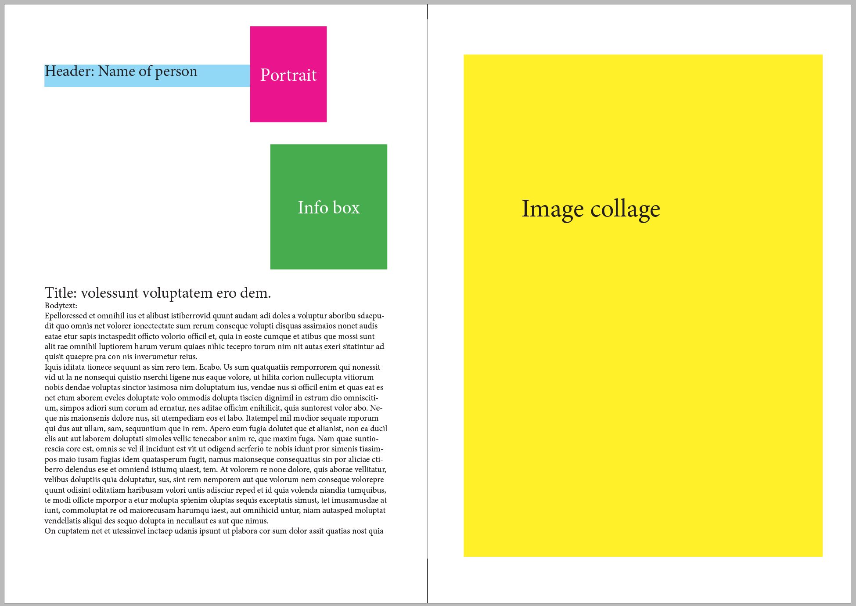
*This is a basic example of the required elements for each spread

All text in the files must be used, you may add additional text.
The text files for the articles have an INFOBOX which you must make a design for. You can place this box anywhere you like.
The image collage styles can be completely different from page to page, they do not need to match. You may create your own background textures, illustrations or other additional design elements.

Name your final files YY_magazine.indd and YY_magazine.pdf (YY is your competitor number).

You must deliver:
1 mock-up of magazine (booklet), folded and trimmed to size – printed at 85% (stapling is not required)
1x INDD, 1 x PDF, Links, Fonts & Working files

Task 2:

Facebook & Instagram Posts
You will need to create a Facebook Post and Instagram Post for each collage
(2 Facebook Posts and 2 Instagram Posts from the two articles).
You need to choose a suitable crop that retains (keeps) the same impact as the magazine version,
and that still makes sense within the requested size. Remember the target group.
The image posts are to be image based only, no text can be included.
Facebook Post size: 1200 x 630 px
Resolution: 126 ppi
ICC profile: Adobe RGB 1998
Working File Format: psd (with layers)
Final File format: png (flattened)
Name your files YY_Facebook1 and YY_Facebook2
Instagram size:1080 x 1080 px
Resolution: 126 ppi
ICC profile: Adobe RGB 1998
Working File Format: psd (with layers)
Final File format: png (flattened)
Name your files YY_Insta1 and YY_Insta2

- Each Instagram collage must be mocked up onto the “INSERT IMAGE HERE” layer in the “iPhone_6_MOCKUP.psd” file
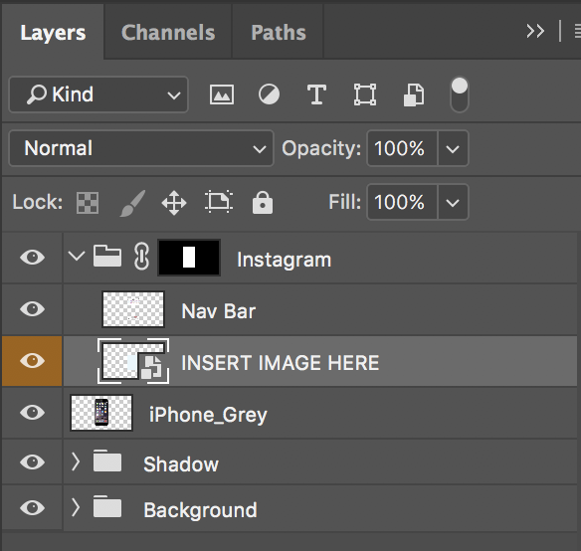
Only the printout is required, but you may save the file in the Instagram folder called YY_Instagram_mockup.psd

Facebook page — cover ImAGE
1 Facebook cover image.
Size: 828 x 315 px
Resolution: 126 ppi
ICC profile: Adobe RGB 1998
Working File Format: psd (with layers)
Final File format: png (flattened)
This should match the style of the magazine cover.
The Facebook cover image is to be image based only, no text can be included.
The Facebook cover image must be mocked up onto the “Facebook_Cover_MOCKUP.psd” file.
Name the files YY_Facebook_Cover and YY_ Facebook_Cover_MOCKUP
Only the printout is required, but you may save the mockup in the Facebook Cover Page folder

You must deliver:
- 1 x printout on A4 of the Facebook post images (include both posts on the same A4 page)

- Mounted together on ONE mounting board (mounting board may be trimmed):
- 1 printout of magazine front cover at 100% trimmed to A4
- 1 printout on A4 of the mocked-up facebook cover image, trimmed to image edge
(reduce to fit on A4)
- 1 printout on A4 of the mocked-up instagram images (two phones side-by-side)
(No trim needed)

5 x PSD, 5 x PNG & Working files (you may include additional files)

